# Maryam Tabatabei

## Web-Design-Challenge

The purpose of this project was to analyze how weather changes as you get closer to the equator. to accomplish this analysis, we first pulled data from the OpenweatherMap API to assemble a dataset on over 500 cities.

After assembling the dataset, we used Matplotlib to plot various aspects of the weather vs the lattitude. Factors we looked at included: temperature, cloudiness, humidity and wind speed. This site provides the visualizations created as part of the analysis as well as explanations and descriptions of any trends and correlations.

Landing Page

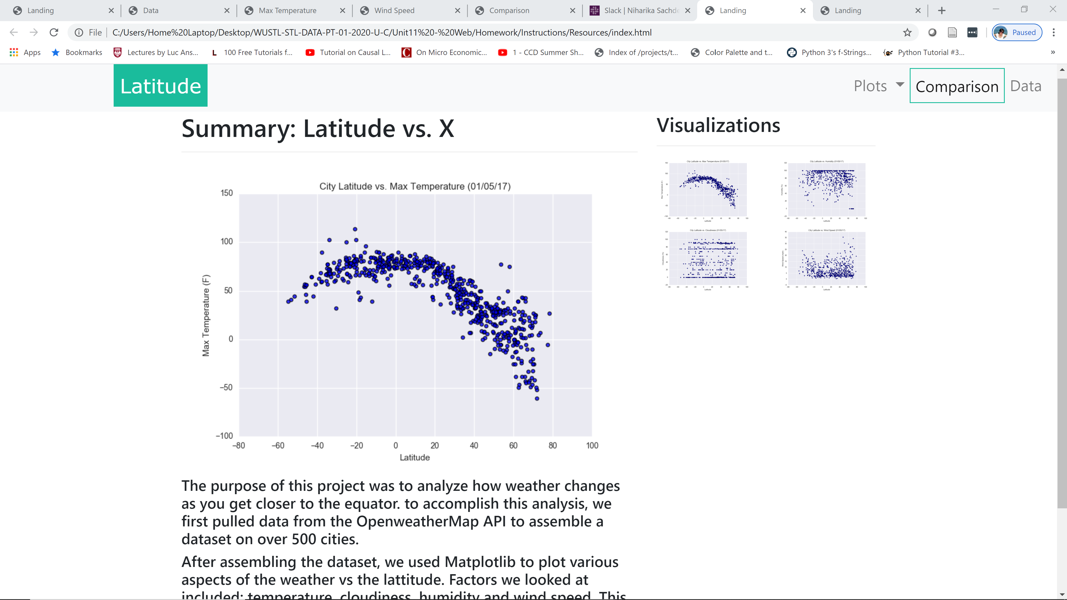

Max Temperature Page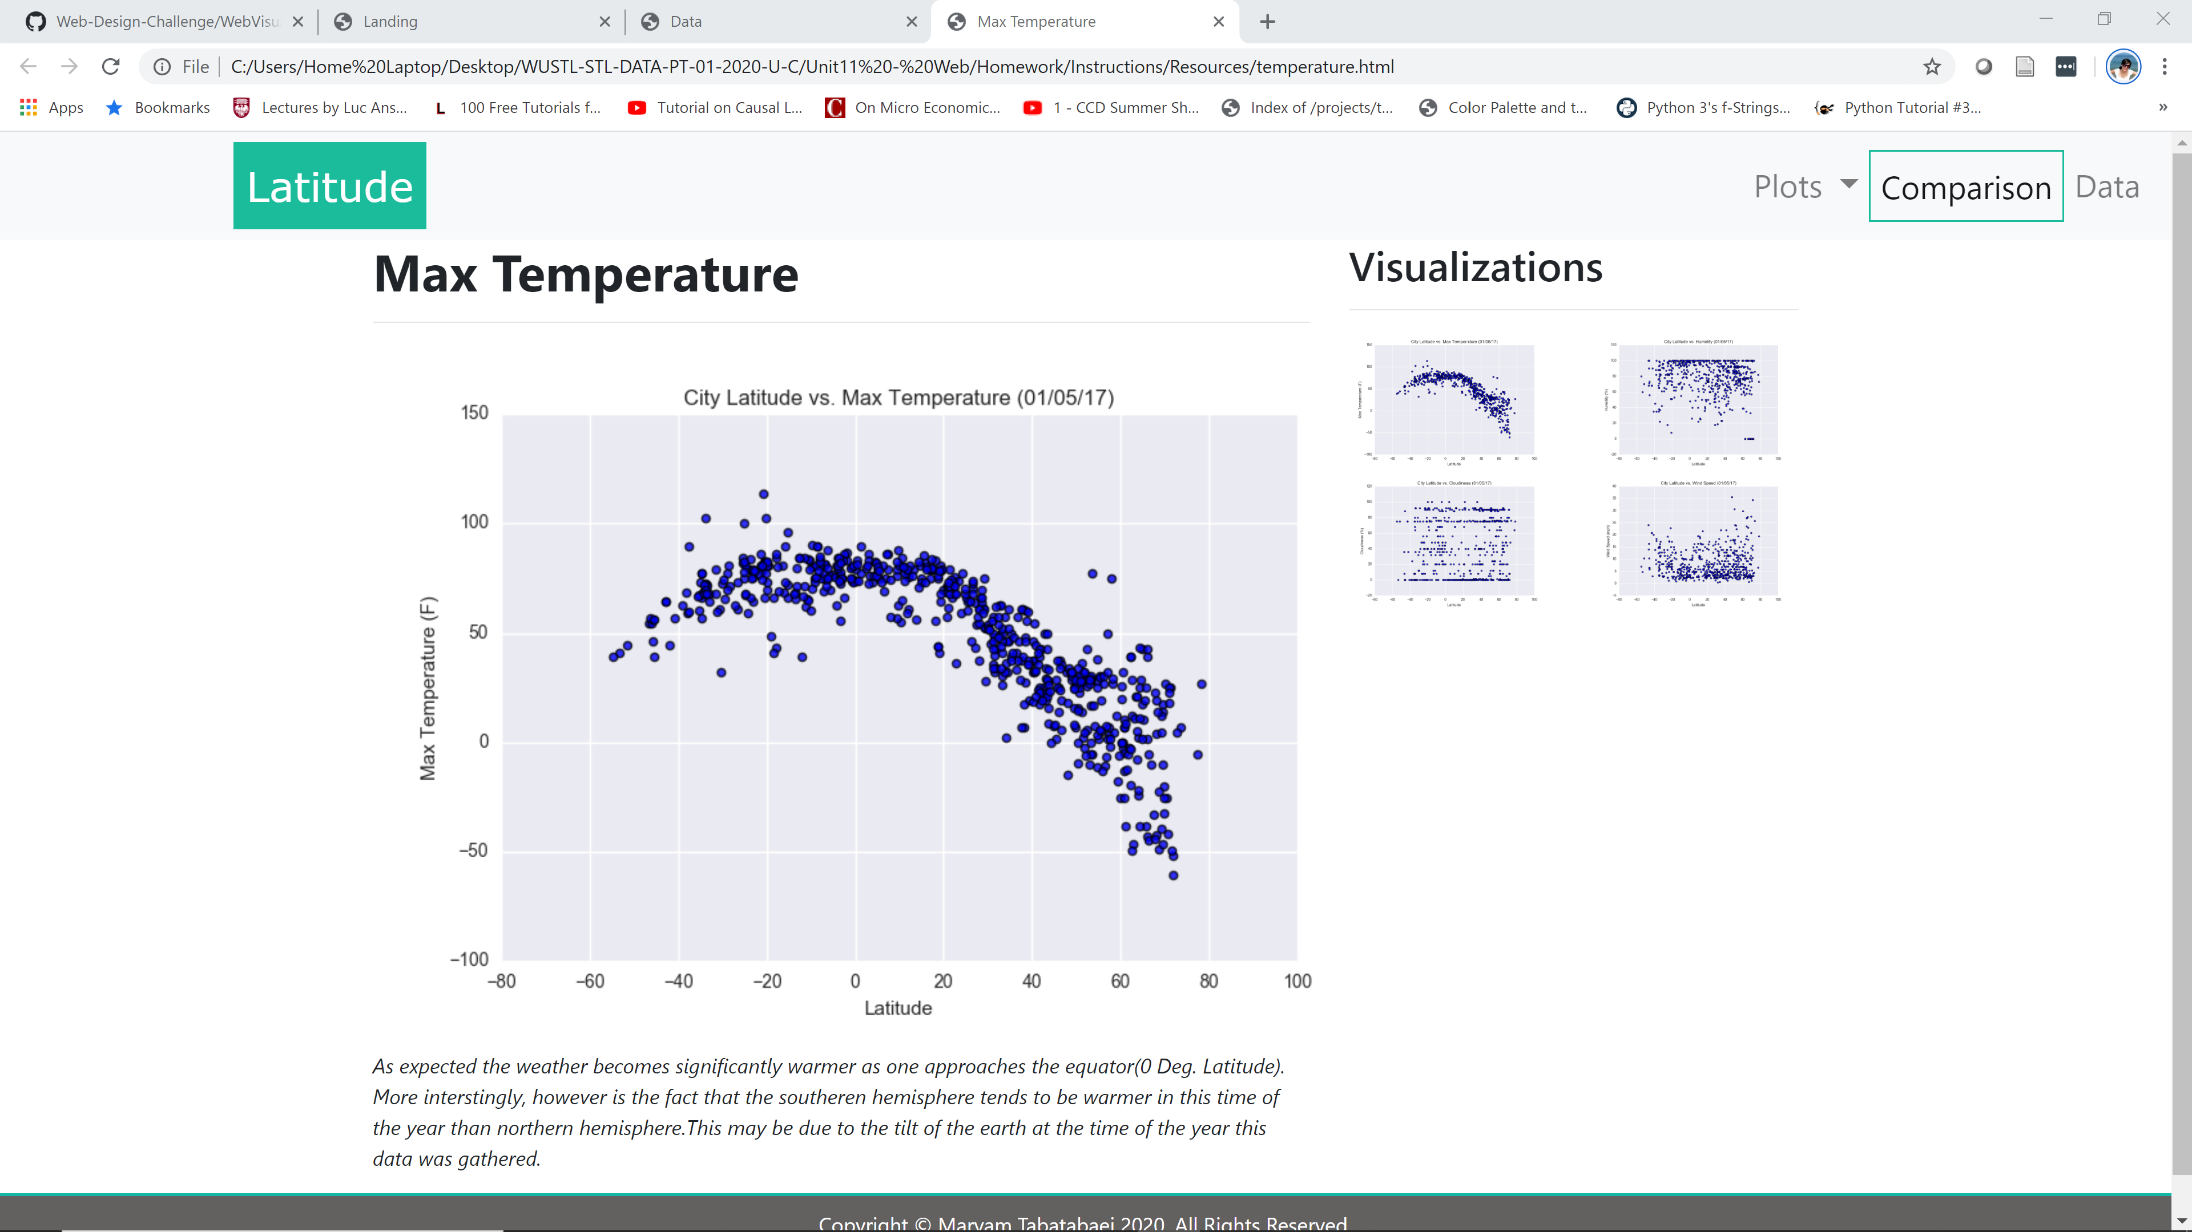

Humidity Page

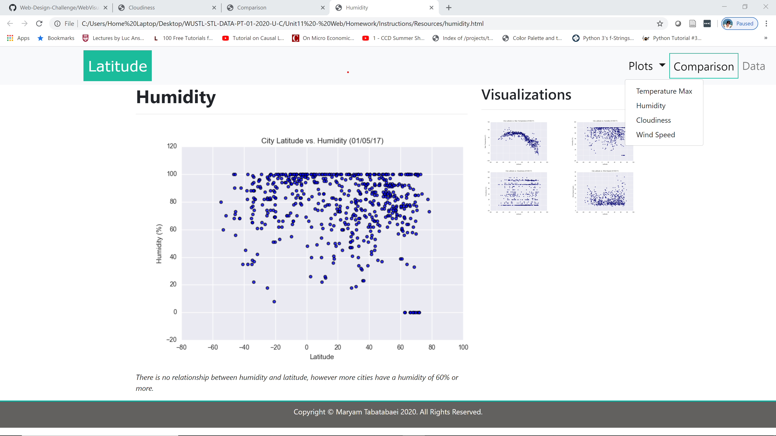

Cloudiness Page

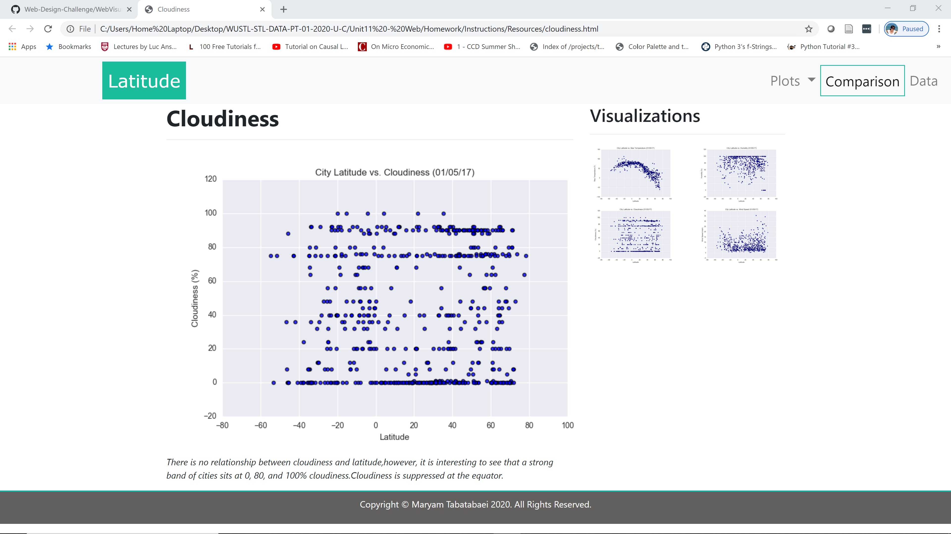

Wind Speed Page

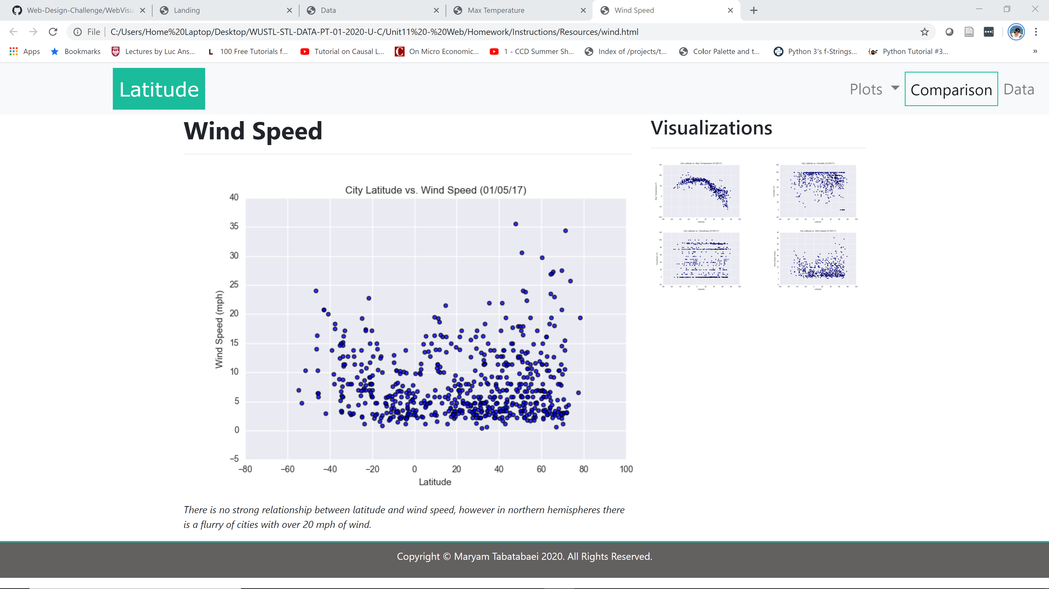

Comparison Page

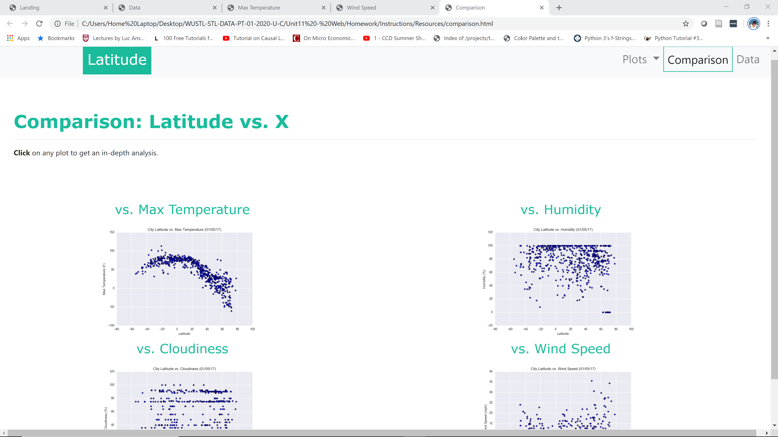

Data Page

